Future of Employee Wellbeing: Unlocking the Full Potential of AI

In a time period when workplace well-being is becoming a cause that is being more persuasively championed for, a generation of younger workers have emerged for whom this issue resonates most strongly. Reports reveal that workplace stress is an issue that extends into personal lives for more than half of Gen Z and Millennial workers while a figure close to that number reported that they would leave their current job for a sphere that more emphasized their personal well-being. This showcases that employee wellbeing is no longer a formality, as it is commonly treated, but a business emergency.

With the rise of artificial intelligence technologies, this cause can be dealt with more efficiently at a lower cost for businesses. The newsletter will unveil the role of AI in improving employee wellness with a narrow lens on the role of nutrition, the limitations of poor work wellness and the implications in curbing burnout while improving mental health and productivity.

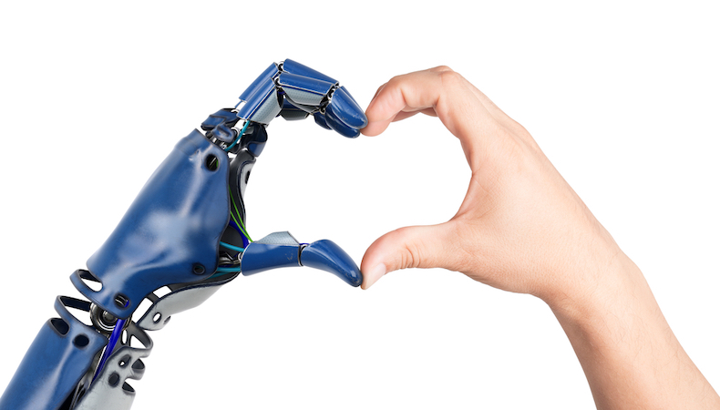

The impact nutrition has on employee wellbeing and productivity is often understated. The WHO states that proper nutrition can improve productivity by up to 20% yet very few wellness programs attack this core issue. AI can be gracefully employed to combat this by providing personalized dietary recommendations, real time meal tracking & feedback and seamless integration with fitness and wellness platforms. This is a comprehensive methodology to fuel both physical and cognitive problems that may arise in the workplace as a result of poor dietary practices.

To shift focus on the economic perspective, the financial burden of ignoring employee wellbeing is substantial. The Centers for Disease Control and Prevention (CDC) estimates that absenteeism costs U.S. businesses $225.8 billion annually, or approximately $1,685 per employee (US figures, hence, can’t be generalized in Indian context due to cultural differences and stigma yet a relevant benchmark with the more aware upcoming generations). AI driven solutions here become incredibly significant given their ease at accessing predictive analytics to identify at risk employees, developing adaptive health programs and providing real time insights to help the HR team refine wellness initiatives.

Along a similar plane, AI’s personalized and predictive powers also help combat mental health and help in the prevention of burnouts. A Forbes report indicates that 84% of employees believe workplace conditions contribute to their mental health challenges. By integrating AI and its constantly adaptive strategies and tailored initiatives, this becomes a much less unsurmountable issue which in turn helps bolster productivity to a great extent.

Hence based on the discussion so far it has been established that AI can help curb absenteeism, enhance cognitive function and focus and thereby lead to greater engagement and morale As AI technology advances, its applications in workplace wellbeing will continue to evolve. Businesses may improve productivity, foster a positive workplace culture, and proactively promote employee wellness by using AI-driven solutions. AI has the ability to optimize all three areas i.e. diet, exercise, and mental health—helping workers maintain higher energy levels, lower stress levels, and enhance overall job results. Businesses that use AI-driven wellness methods will be in the greatest position to create teams who are healthier, happier, and more engaged as long as employee health is prioritized.

